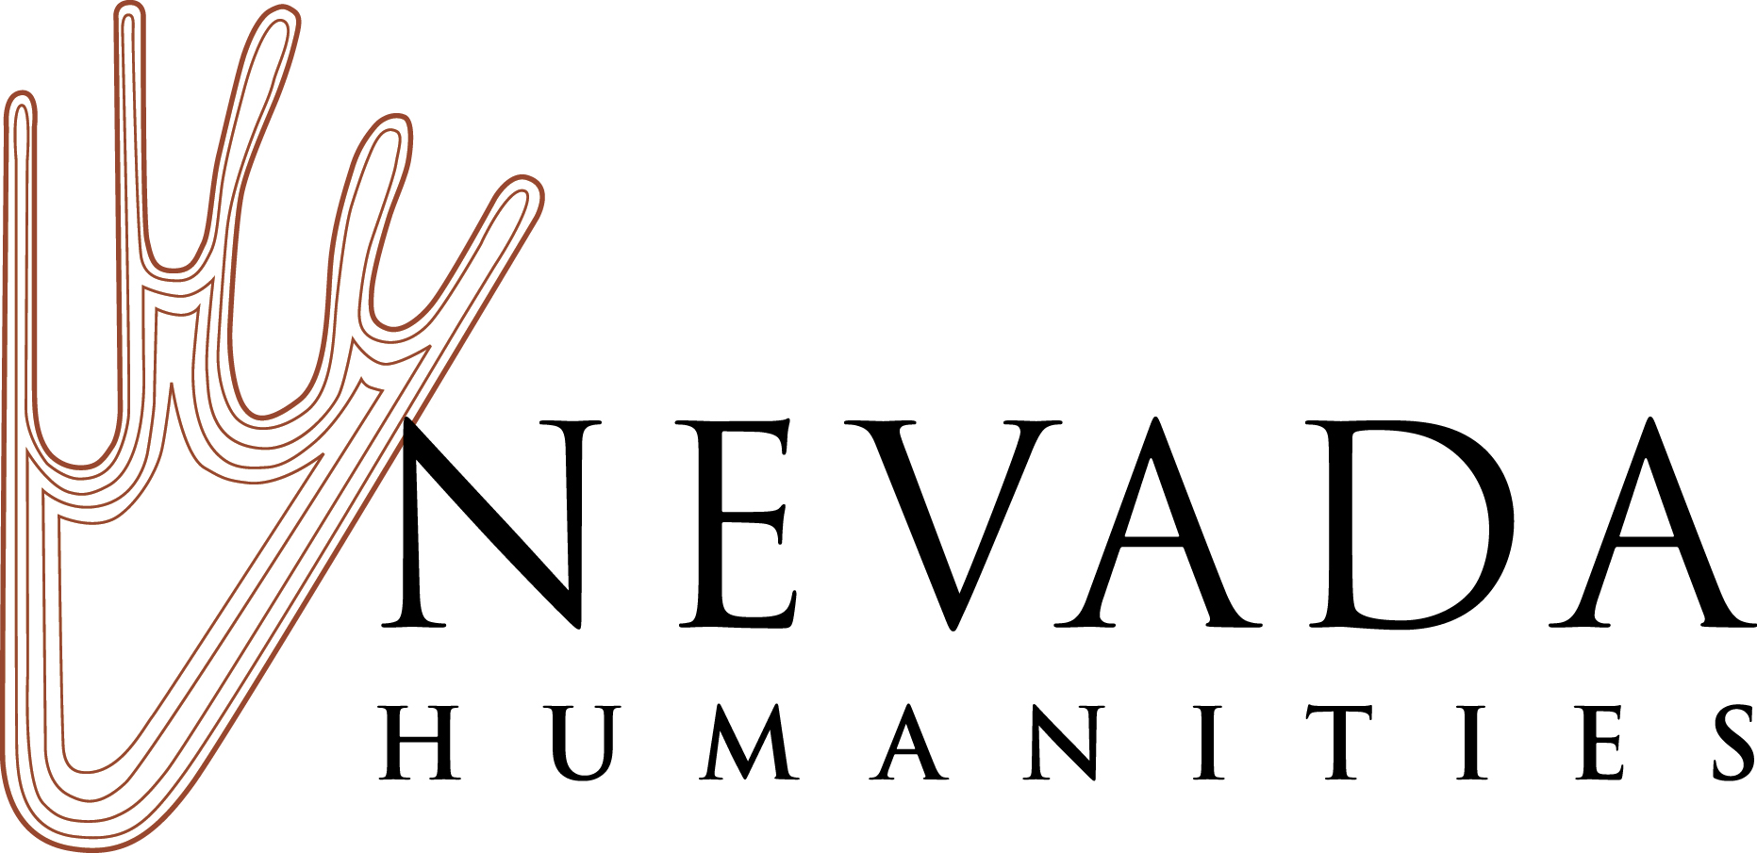

2019 Nevada Humanities Awards Guidelines and Call for Nominations
Nomination Deadline is February 15, 2019

Nevada Humanities biannually presents five awards, which recognize individuals and organizations that foster cultural enrichment and deepen our understanding of the human experience by facilitating opportunities for Nevadans to engage with the humanities. In addition to the Judith Winzeler Award for Excellence in the Humanities, Nevada Humanities adjudicates awards to honor outstanding humanities advocacy, teaching, and public humanities programming. Nevada Humanities invites nominations for the 2019 awards; nominations open on December 3, 2018. Nomination guidelines are available at nevadahumanities.org. The postmark deadline for all award nominations in all categories is February 15, 2019.

Judith Winzeler Award for Excellence in the Humanities
Nevada Humanities welcomes nominations for the Judith Winzeler Award for Excellence in the Humanities. This lifetime achievement award recognizes an individual, organization, or business that has made an outstanding and long-term contribution using the tools of the humanities to strengthen and enhance the lives of Nevadans. The Nevada Humanities Board of Trustees established this award in 2008 to honor the exemplary work of Judith Winzeler, who served as executive director of Nevada Humanities from 1984 to 2009. CRITERIA: The letter of nomination should address the following criteria: 1) the nominee’s demonstrated outreach in the community they serve; 2) the nominee’s imaginative leadership and creative vision; and 3) the broad and cumulative impact of the nominee’s work on the lives of Nevadans throughout their term of service.

Humanities Rising Star Award
The Humanities Rising Star Award recognizes a person who has made contributions to the humanities in Nevada, and has demonstrated the potential for leadership and continuing service in creating a state where people thrive in just and healthy communities, where connection and participation are part of everyday life, and where diverse perspectives are welcomed and valued. This award is given based on the total experience of the nominee, including knowledge, leadership, participation, and/or achievements within their community. CRITERIA: The letter of nomination should describe the nominee’s activities, leadership, and service to their community through the humanities in Nevada.

Friend and Champion of the Humanities Award
The Friend and Champion of the Humanities Award recognizes a business, organization, foundation, or individual for exemplary service in helping to advance the humanities in Nevada through partnership, funding, sponsorship, policy making, public advocacy, or other activities. CRITERIA: The letter of nomination should describe the nominee’s activities, leadership, and impact in advocating for, and expanding understanding and appreciation of, the humanities in Nevada.

Outstanding Teaching of the Humanities Award
The Outstanding Teaching of the Humanities Award recognizes a Nevada educator, administrator, school district, school, or education program for excellence and innovation in humanities teaching at any level (early childhood, K-12, higher education, lifelong learning). CRITERIA: The letter of nomination should address the nominee’s innovation, creativity, and effectiveness in humanities teaching.

Outstanding Humanities Project Award
The Outstanding Humanities Project Award honors an outstanding humanities project made possible by a Nevada Humanities grant or partnership. Nominations are now open for projects that took place between January 1, 2017 and December 31, 2018. CRITERIA: The letter of nomination may address how the project has presented the humanities in a creative or innovative way, fostered cultural enrichment and connection for Nevadans, inspired meaningful public engagement with humanities concepts, demonstrated exceptional scholarship, deepened our collective sense of place and belonging in Nevada, and/or encouraged mutual understanding.

How to Submit Your Nomination
A nomination may be made by any individual or organization, but the Outstanding Humanities Project Award may be nominated only by the project’s sponsoring organization. All other nominations must come from a third party (individual or organization). Multiple nominations may be submitted in the same or different award categories. Nevada Humanities reserves the right to move nominations to appropriate categories if needed. Current members of the Nevada Humanities board or staff (or immediate family members) are not eligible for Nevada Humanities awards. Award recipients are selected by members of the Nevada Humanities Board of Trustees. Awardees will be notified in March 2019. The awards will be presented in a special ceremony at the Nevada Museum of Art, in Reno, on Thursday, April 18, 2019. All awardees must be present to receive their awards.

The postmark deadline for nominations in each award category is February 15, 2019. Cover sheet is below. Each of your nominations should consist of three parts:

☐ Nomination Cover Sheet
☐ Letter of Nomination (no more than three pages long)
☐ Up to three Letters of Support

Submit your nomination packet(s) to Nevada Humanities via email to Aliza Pantoja at apantoja@nevadahumanities.org, by fax, or US Post. For more information please contact Nevada Humanities.

Nevada Humanities
P.O. Box 8029
Reno, NV 89507
Tel: 775‐784-6587 Fax: 775‐784-6527
nevadahumanities.org

Nevada Humanities
Call for Nominations – 2019 Nevada Humanities Awards
Contact: Christina Barr, Executive Director
775‐784‐6587, cbarr@nevadahumanities.org

Nomination Cover Sheet
2019 Nevada Humanities Awards

Postmark Deadline: February 15, 2019

Award Category (please select one)

☐ Judith Winzeler Award for Excellence in the Humanities
☐ Humanities Rising Star Award
☐ Friend and Champion of the Humanities Award
☐ Outstanding Teaching of the Humanities Award
☐ Outstanding Humanities Project Award

Nominee Information

Name:___________________________________________

Address:__________________________________________

City: State: Zip:

Phone: Email:

Organization/Title:

Nominator Information

Name:

Address:

City: State: Zip:

Phone: Email:

Organization/Title:

Past Nevada Humanities Awardees

Nevada Humanities Award
1990 Edythe Katz, Boulder City; Robert Maxson, Las Vegas; Eugene Moehring, Las Vegas; Harrah’s Hotel and Casino, Las Vegas
1991 Robert Gorrell, Reno; Joanne Walen, Reno; Wilbur Stanley Shepperson, Reno; John Ben Snow Memorial Trust, Reno
1992 Wilber Stevens, Las Vegas; Ralph Roske, Las Vegas; R. Guild Gray, Las Vegas
1993 Robert Laxalt, Reno; Elmer Rusco, Reno; Western Folklife Center, Elko
1994 Frank Wright, Las Vegas; Karla McComb, Las Vegas; Jean Ford, Carson, City; KNPR Nevada Public Radio Corporation, Las Vegas; Nevada Shakespeare in the Park, Henderson
1995 Rollan Melton, Reno; William Douglass, Reno; James Hulse, Reno
1996 Junior League of Las Vegas, Las Vegas; Thomas Wright, Las Vegas; Sue Fawn Chung, Las Vegas; Senator Harry Reid, Searchlight
1997 Costadina Titus, Las Vegas
1998 Susan Tchudi, Reno; Frank Mullen, Jr., Reno; Catherine Fowler, Reno
1999 Boulder City Museum and Historical Society, Boulder City
2000 Doris Dwyer, Fallon; Charles Greenhaw, Elko; Anne Howard, Reno; Clay Jenkinson, Reno; Stephen Tchudi, Reno; Reno Gazette-Journal, Reno; The E.L. Cord Foundation, Reno
2001 Glenn Schaeffer, Las Vegas; William Metscher, Tonopah; Christopher Hudgins, Las Vegas; Lied Discovery Children’s Museum, Las Vegas; Las Vegas Senior Center Humanities Discussion Group, Las Vegas; Howard Hughes Corporation, Las Vegas
2002 Beverly Crum, Earl Crum, and Steven J. Crum, Owyhee; Warren L. d’Azevedo, Reno; William H. Jacobsen, Jr., Reno
2003 Sherman Frederick, Las Vegas
2004 Scott Slovic, Reno

Nevada Arts & Humanities Award for Public Service
(Jointly presented by Nevada Humanities and the Nevada Arts Council)
1999 Senator Richard Bryan, Las Vegas; Senator Harry Reid, Searchlight
2000 Joe Crowley, Reno
2001 Danny Greenspun, Las Vegas
2003 N. Edd Miller, Reno
2004 Costadina Titus, Las Vegas; Ray Rawson, Las Vegas
2011 Joseph E. Dini, Jr., Yerington; William J. Raggio, Reno
2017 Susan Boskoff, Reno

Judith Winzeler Award for Excellence in the Humanities
2008 Judith Winzeler, Reno
2011 Wally Cuchine, Eureka; Sundance Books and Music, Reno
2013 Joe Crowley, Reno; Carol Harter, Las Vegas
2015 Phil Boardman, Reno; Trish Geran, North Las Vegas
2017 Patrick Gaffey, Las Vegas; Marilyn Melton, Reno

Friend and Champion of the Humanities Award
2013 Richard Hooker, Las Vegas
2015 Shelley Berkley, Las Vegas; Robert Z. Hawkins Foundation, Reno
2017 Linda Duffurena, Denio; Steven Nightingale, Palo Alto, CA

Outstanding Teaching of the Humanities Award
2013 June Sylvester Saraceno, Incline Village
2015 Core Humanities Program, University of Nevada, Reno; Milton Hyams, Incline Village; Jim Roderick, Reno; Kim Russell, Las Vegas
2017 Cheryll Glotfelty, Reno; Gailmarie Pahmeier, Reno

Outstanding Humanities Project Award
2013 Project REAL, Las Vegas; National Automobile Museum, Reno
2015 Holland Project and Sundance Books and Music, Reno; Junior League of Las Vegas, Las Vegas

